- Introduction

In the present Sri Lankan context, the need to learn Mathematics at School Level has increased considerably due to the noteworthy percentage of failures generated each year for the subject at the annual Ordinary Level Examination. One of the major reasons for this disappointing turn of events is the lack of quality School Input by teachers, due to numerous restrictions and externally influenced factors.
Still in this era, Sri Lanka is struggling to move forward with the Student Centered Model of Learning. Instead, it has become an unbalanced hybrid, which is still vastly dependent on the teacher. The emergence of new technological innovations, such as E-Learning; has paved the way for more approachable and feasible Educational Instruments to be developed. However, the deciding factor- a feasible structure for true implementation is, as of yet, still being thrown about between various individual efforts, and lacks a proper initiative; which considers Student Participation as its core-interest.
But by integrating distance learning methods with a locally executable approach, computer software can access this core-interest effectively, while bridging technically difficult challenges more practically. MOLE, or Mathematics for Ordinary Level Examination; is a Software Project which carries the potential to address this need. MOLE is an Electronic teacher which would help students to work with difficult calculations and at the same time, intuitively teach them how to solve them on their own.
The School chosen for the implementation of the Project is- JMC International School, Kaduwela. And while being a private and non-national school, it suits the nature of the project very well, and presents several requirements which could ideally be addressed by our implementation.
MOLE is based upon the 4 current National Textbooks and the 2 accompanying Teachers Guides, prepared by the National Institute of Education, Maharagama. This makes it fully compatible and compliant with the annual O/L Examination.
The 2 basic components of the project; the Software and the Website, considers technical, fiscal and user factors in its deployment. These would be detailed further in the proceeding sections of this report.

- Problem Definition

Identified Scenario: A student goes to School and listen to his/her Math teacher, and after School goes to tuition and listens to the tuition master and comes home. After that, he starts to study/practice Math, but suddenly he/she find a problem that he/she can't solve or doesn't know whether the solved answer is correct. So, the student would think, "I will run to Math teachers’/ tuition masters’ home to ask for the answer", is this practical?

This is the basic problem faced by the average O/L Student as identified by us, and is the basis for our project modeling.

It’s made for both regular O/L School Applicants and repeat Candidates. The Project was done in English.

III. Software Requirements

The MOLE Software would include the following data inputs form the User:
- User Account Information
- Lesson Status Details
- Examination Submissions
The utilized Programming Languages for the Software are:
- Microsoft Visual C++
- Java
- J2EE
The utilized Programming Languages for the Website are:
- HTML
- mySQL (for dB)
- PHP
- JavaScript
- AJAX

The Software used to design the Project are:

- Microsoft Visual Studio
- Adobe Dreamweaver
- Oracle NetBeans
- WampServer
- Adobe Photoshop
The main identified list of requirements includes:
- Understandable Lessons
- Straight-forward Examinations
- A controllable method of communication between Peers
- Workable Calculators
- A feasible and customizable interface
- A centralized hub for the Software and overall Project

IV. Software Functionalities and Components

The main components of the Project are:
- Software

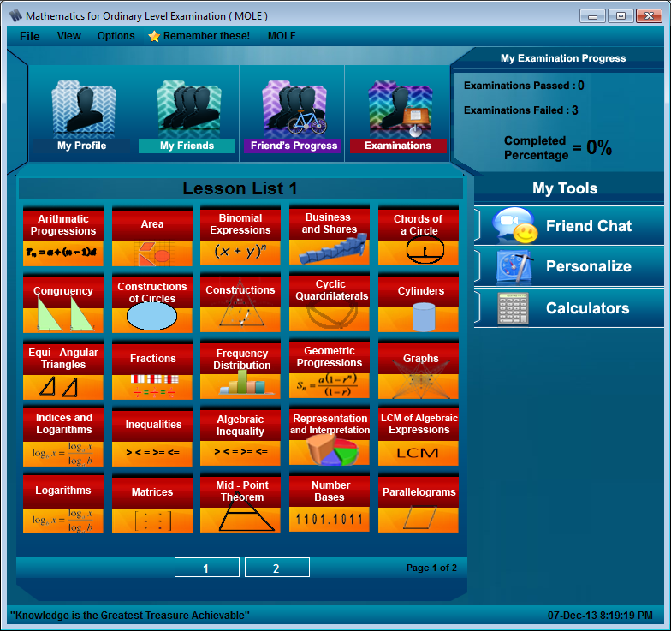

- Website, with database

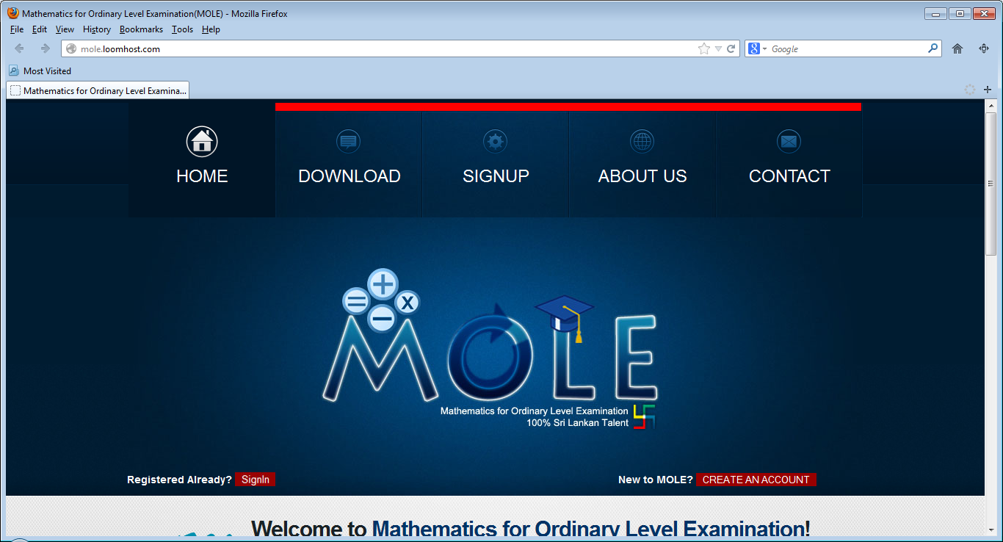
The main functions to be performed by the Software, according to the requirements are:

- Correct and understandable Subject explanations and details; with examples, formulas and notational charts

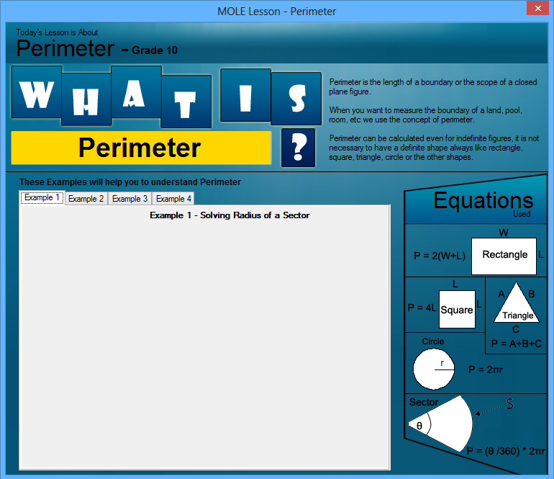

- Useful Calculators for the Student

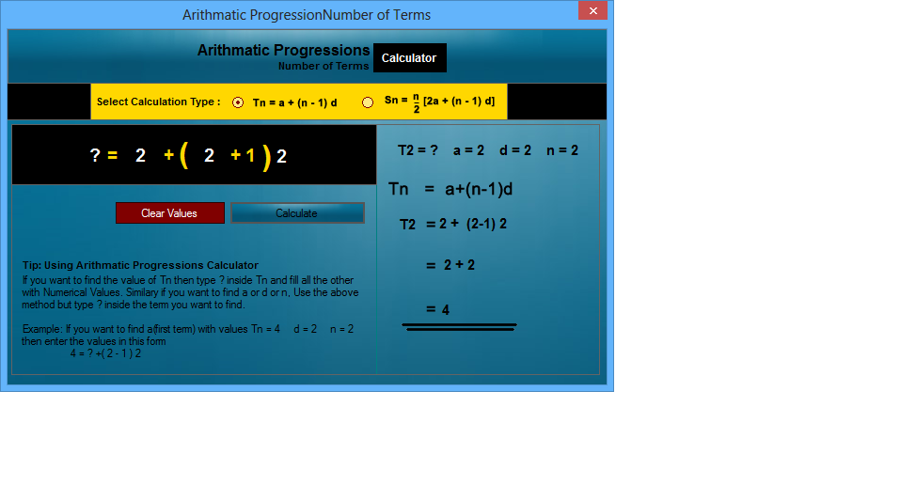

- Challenging, yet enjoyable Examinations

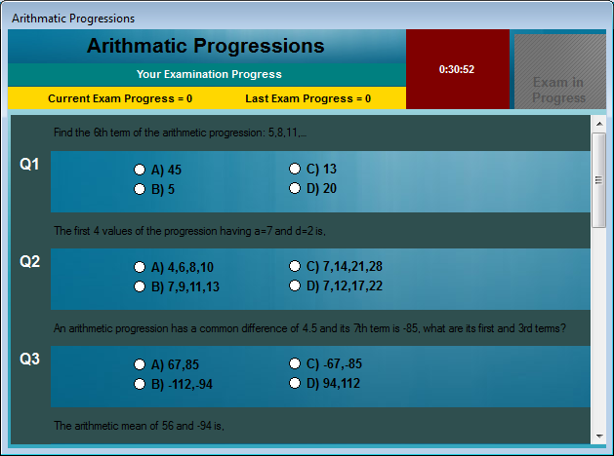

- A tracking and chat system of users’ Friends
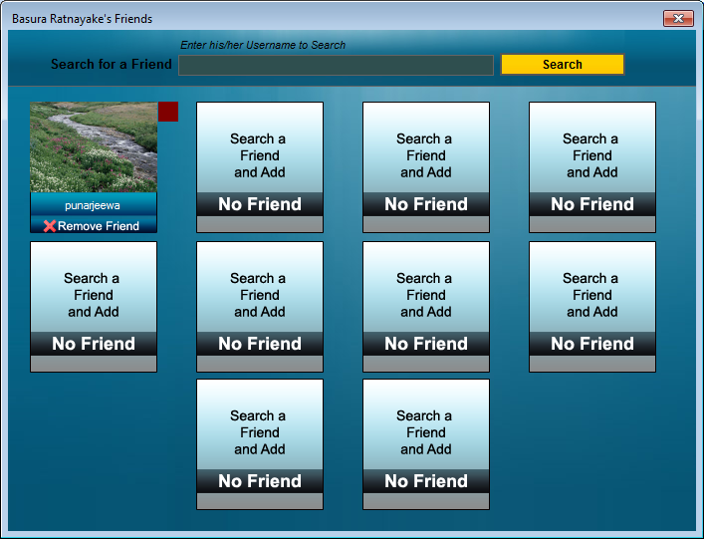
- A customizable UI
The features of the website (and accompanying dB) are:
- Management of User Profiles
- A hub for download of the Software

- Advantages to the User

“Think not Math as another war to fight but as a challenge worthy of taking”
- The MOLE Team -
The major advantages to be gained by the User through the implementation of the Software, with website are:
- Since it’s based on the National Curriculum, it’s the perfect accompaniment for the Student, whose only ally is his/ her textbook
- Real-time Lesson comprehension and accurate calculators makes the daily burden of the Student far less cumbersome
- Learning virtually would motivate, inspire and fascinate the regular Student
- Student could work at both Home and School
- Strategic chat time-outs would keep the Students’ mind on Math
- Totally Free-of-charge Software
- Both Online and Offline Work Modes, less resource consumption and throughputs

- User Resource Management

The Software is designed to run on a fairly low-end machine, and as such, would use only a few system requirements. However, it does need several pre-installed Environments and Packages to be present on the Machine. These would not be bundled in the Software Setup due to the increase in size (which would only be nearly about 100MB). The main system requirements are-
Operating System: Microsoft Windows 7/ 8
Disk Capacity: About 100MB
User Requirement: An online MOLE Account
Additional Packages required: Microsoft .NET Framework, Java Runtime Environment

